Q.1 wap to print number 1 to 100.

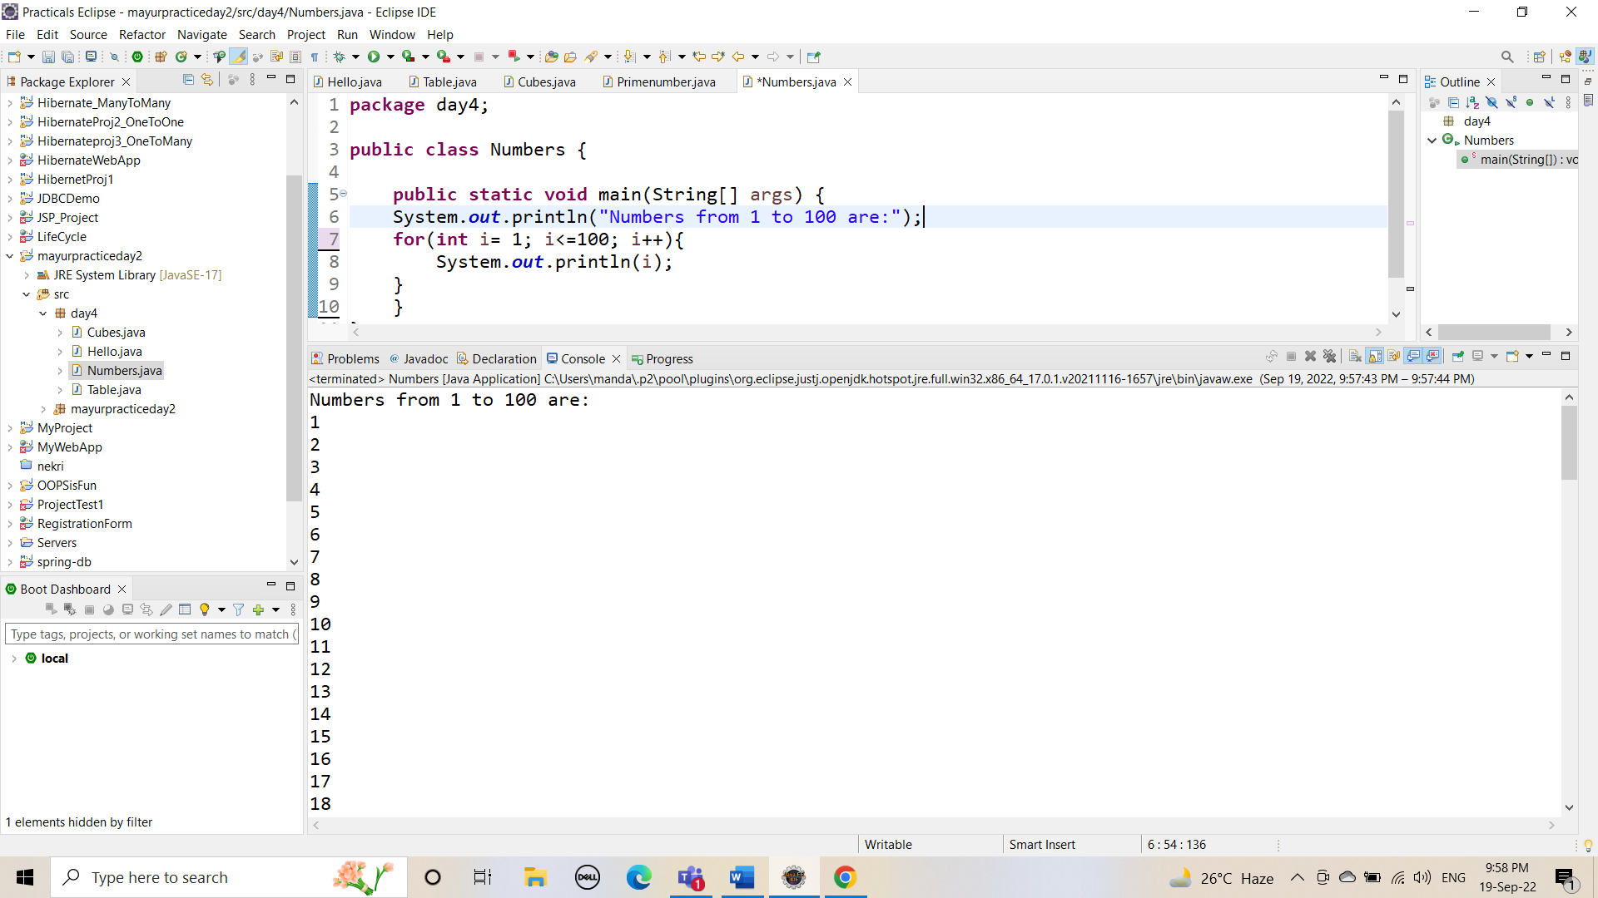

Q.2 wap to print even numbers between 1 to 20

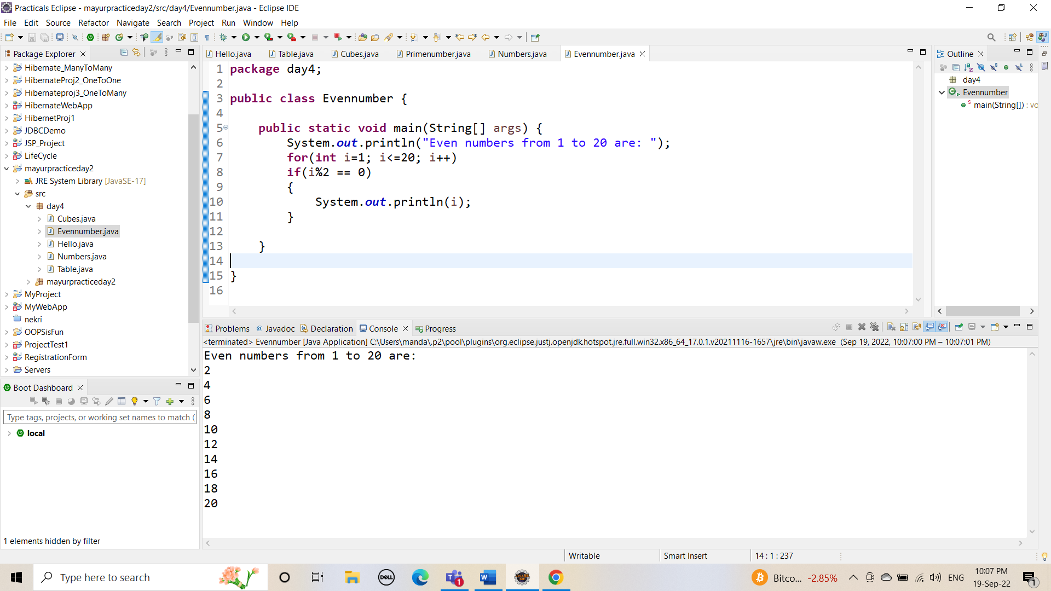

Q.3  wap to print cube of 1 to 5 number.

